December 16th, 2007
Hi
Not much to write about. Still warm for this time of the year. I went to the Tuen Mun hospital for their check up. Last went in June (?July) but requested less frequent appointments as they do very little. Next appointment is for April.
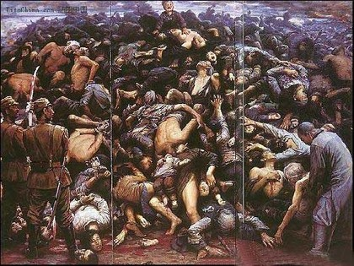
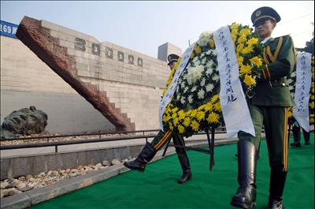
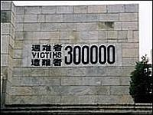
Thursday, was the 70th anniversary of the Nanjing massacre, when, in 1937, Japanese forces occupied what was then the capital of China and committed numerous atrocities on its civilian population. A ceremony took place in a newly renovated museum dedicated to the dead. China puts the number killed at more than 300,000, although Japanese estimates are far lower.

In Rugby, the Crusaders’ coach has been selected to coach the Wallabies. This is the first time a foreign coach has been used to coach the Australian rugby team.
In HK, two double-decker buses (one empty) collided the other night with several passengers being killed. The driver of the empty bus drove through a ‘Stop’ sign and has been arrested for dangerous driving causing death.
Tough run yesterday – the Cloudy Hill area (and as I probably remind you every year, the hill where Gavin accidentally started the small motor many year ago). It was the first time this season I ran one over 3 hours; took 3hr 7 min, which was 12 min slower than last year. This is a route where I can make detours thus shortening the distance but in the end decided to do the complete distance. First half was OK but then started flagging.
That’s about it for now.
Cheers

